**Issue 1**

On the Media/Press page James Bond 007 Museum text element below the image is incorrectly displayed

**Used Device/Browser:**

- Chrome (Version Version 80.0.3987.116 (Official Build) (64-bit) on Windows 10

**Steps to reproduce:**

- Open the <http://www.007museum.com/>page

- Click on the link [Media/Press](http://www.007museum.com/gunnar_schafer.htm)

- The Media/Press page will be displayed

- scroll down

- Check this part of the page

- It is not displayed correctly

- The text below the image is incorrectly displayed

Screenshot:

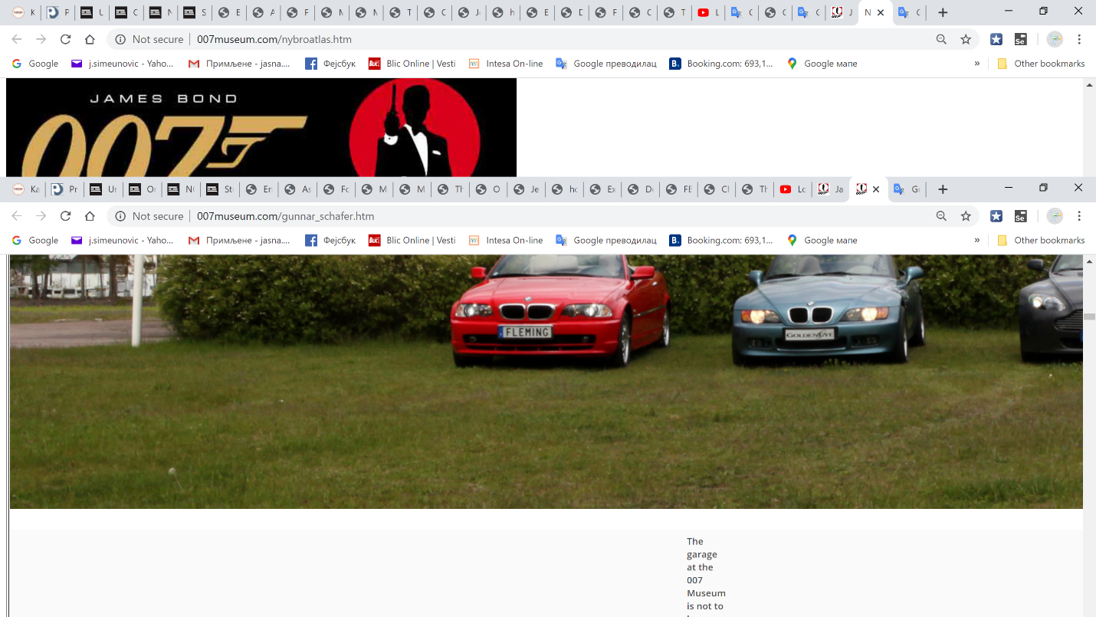

**Issue 2**

On the page James Bond 007 Museum Nybro Sweden text elements overlap

**Used Device/Browser:**

- Chrome (Version Version 80.0.3987.116 (Official Build) (64-bit) on Windows 10

**Steps to reproduce:**

- Open the <http://www.007museum.com/>page

- Click on the link [James Bond 007 Museum Nybro](http://www.007museum.com/nybroatlas.htm) [Sweden](http://www.007museum.com/nybroatlas.htm)

- The James Bond 007 Museum page will be displayed

- scroll down to half a page

- Check this part of the page

- It is not displayed correctly

- Text elements overlap

Screenshot:

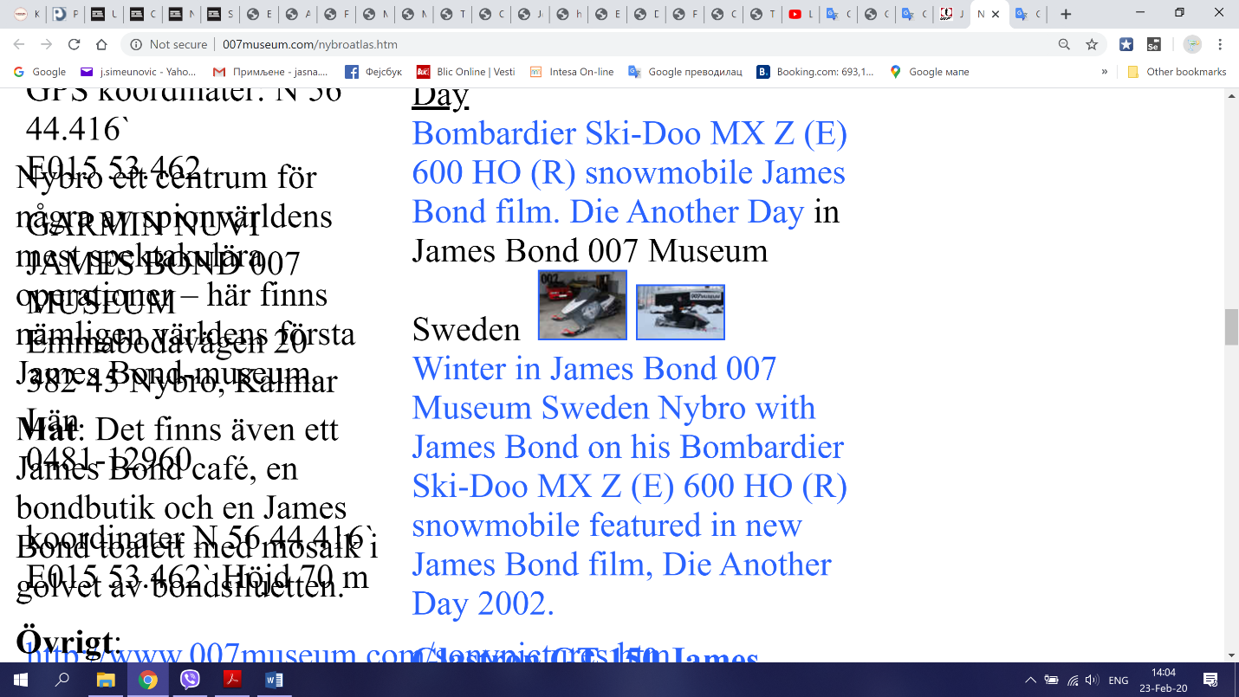

**Issue 3**

On the page James Bond 007 Museum Nybro Sweden the elements are misplaced

**Used Device/Browser:**

- Chrome (Version Version 80.0.3987.116 (Official Build) (64-bit) on Windows 10

**Steps to reproduce:**

- Open the <http://www.007museum.com/>page

- Click on the link [James Bond 007 Museum Nybro](http://www.007museum.com/nybroatlas.htm) [Sweden](http://www.007museum.com/nybroatlas.htm)

- The James Bond 007 Museum page will be displayed

- scroll down

- Check this part of the page

- It is not displayed correctly

- The texts, links and pictures are misplaced

Screenshot:

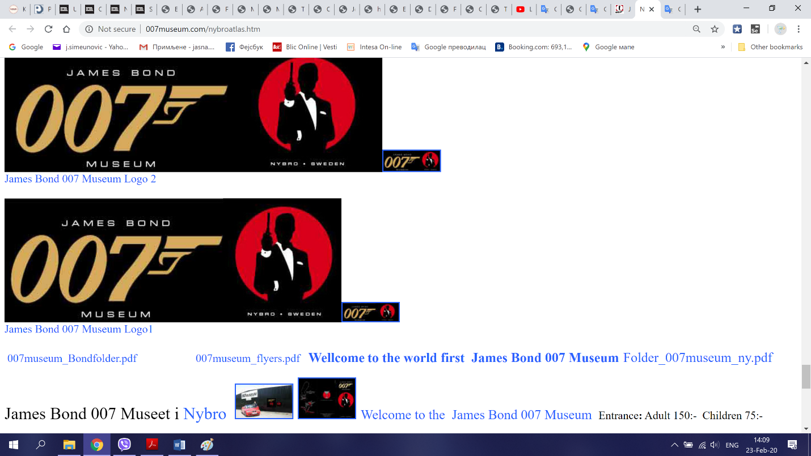

**Issue 4**

On the Bollinger_007_50 page the pictures on the page are too big

**Used Device/Browser:**

- Chrome (Version Version 80.0.3987.116 (Official Build) (64-bit) on Windows 10

**Steps to reproduce:**

- Open the <http://www.007museum.com/>page

- Click on the link <http://www.007museum.com/Bollinger_007_50.htm>

- The Bollinger_007_50 page will be displayed

- scroll down

- Check this part of the page

- It is not displayed correctly

- The pictures on the page are too big

Screenshot:

<https://recordit.co/lw7nmLuBMy>

**Issue 5**

On the Booking ticket entre page the all elemnents on the page are placed in no order

**Used Device/Browser:**

- Chrome (Version Version 80.0.3987.116 (Official Build) (64-bit) on Windows 10

**Steps to reproduce:**

- Open the <http://www.007museum.com/>page

- Click on the link [Booking ticket entre](http://www.007museum.com/entre.htm)

- The entre page will be displayed

- scroll down

- Check the page

- It is not displayed correctly

- The all elemnents on the page are placed in no order

Screenshot:

<https://recordit.co/fwJkq8zz3W>